Centre for Impacting Lives
Aiming for a sustainable, truly African future.

Reg. No 2011/35

CENTRE FOR IMPACTING LIVES OVC

PROJECT AKA “THE NOBLES”

AND

NUTRITION PROJECT IN LESOTHO.

Supported by RAIN
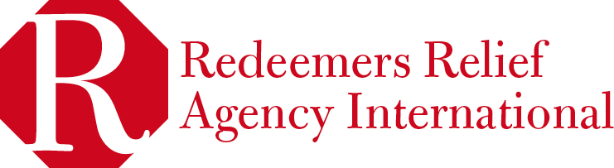

ABOUT US

Centre for impacting Lives (CIL) is a Non governmental not for profit organization in
Lesotho established and registered in February 2011 to take care of HIV/AIDS community outreach, community development, household strengthening, and also the OVC project, Impacting Lives of Orphans and Vulnerable children in Lesotho. CIL is relatively new and focusing on collaborating with both external and internal NGOs and individuals that are experts in their field of operation, so that we are adequately equipped to effectively deliver our services.

THE OVC PROJECT AKA “THE NOBLES”.

This project cares for street Children in Lesotho between the ages of 7- 18 years. It targets rehabilitating and reintegrating street kids and juvenile delinquents into their homes and society as well as restorative justice. The centre presently has twenty five street kids in its care. We provide them with weekly psychosocial and spiritual counseling, personal hygiene and sanitation support, breakfast and lunch, and also their basic health needs.

These children are picked up on Sunday mornings at about 6.30am from the street of Maseru where they live and call home and are brought to the church premises where they have their bath, change their clothes, eat breakfast and join the rest of the church for service and after wards they get a counseling session from a group of volunteer counselors. After these activities, they have lunch but sadly we return them back to the street as we are not able to house them presently. However we make a point of duty to visit them often on the street and follow up on their daily activities.

Our experience with these groups, we discover that these children have made the street their homes as a result of violence, negligence and poverty they face at home. However, the streets are even worse as they are exposed to the high risk of exploitation, use and abuse of drugs and to other different immoral practices.

Some pictures of where the children on the street live.
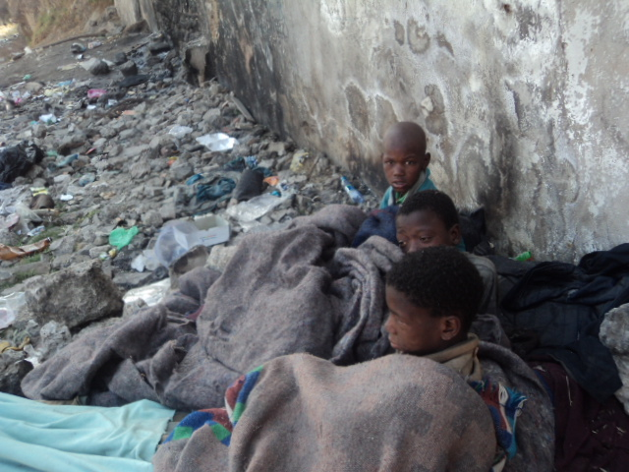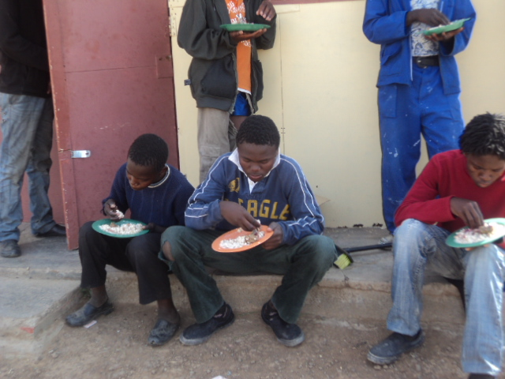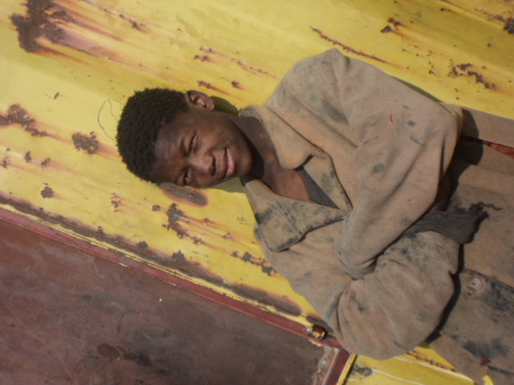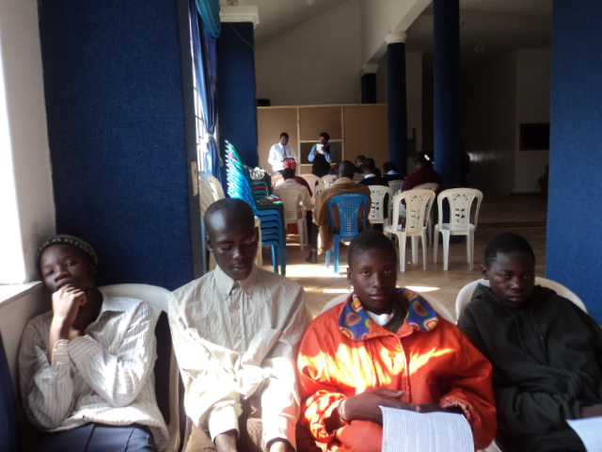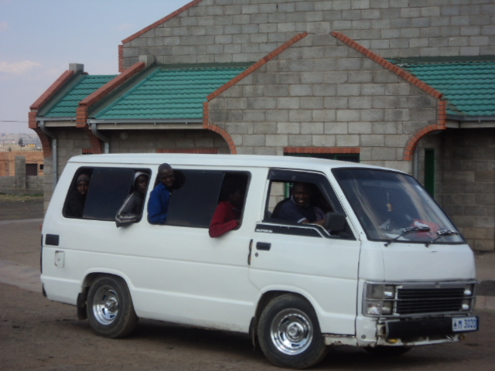

NUTRITION PROJECTS

The nutrition projects cares for 24 orphaned children between the ages of 1year to 16 years in the Bertha side orphanage in Teyateyane in Berea district and also 20 malnourished infants/children in Ha Ramorakane in Maseru whose families are affected or infected by HIV/AIDS.
CIL supports the orphanage by providing them clothing and feeding items periodically. The orphanage is owned by a couple who rely on the generous support of individuals to feed, clothe and send these children to school. These children live under deplorable conditions, despite the hard work these couples put into it.

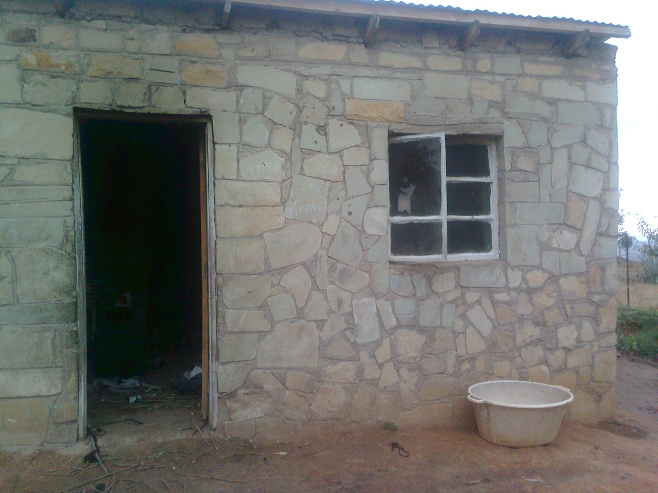
The house they live
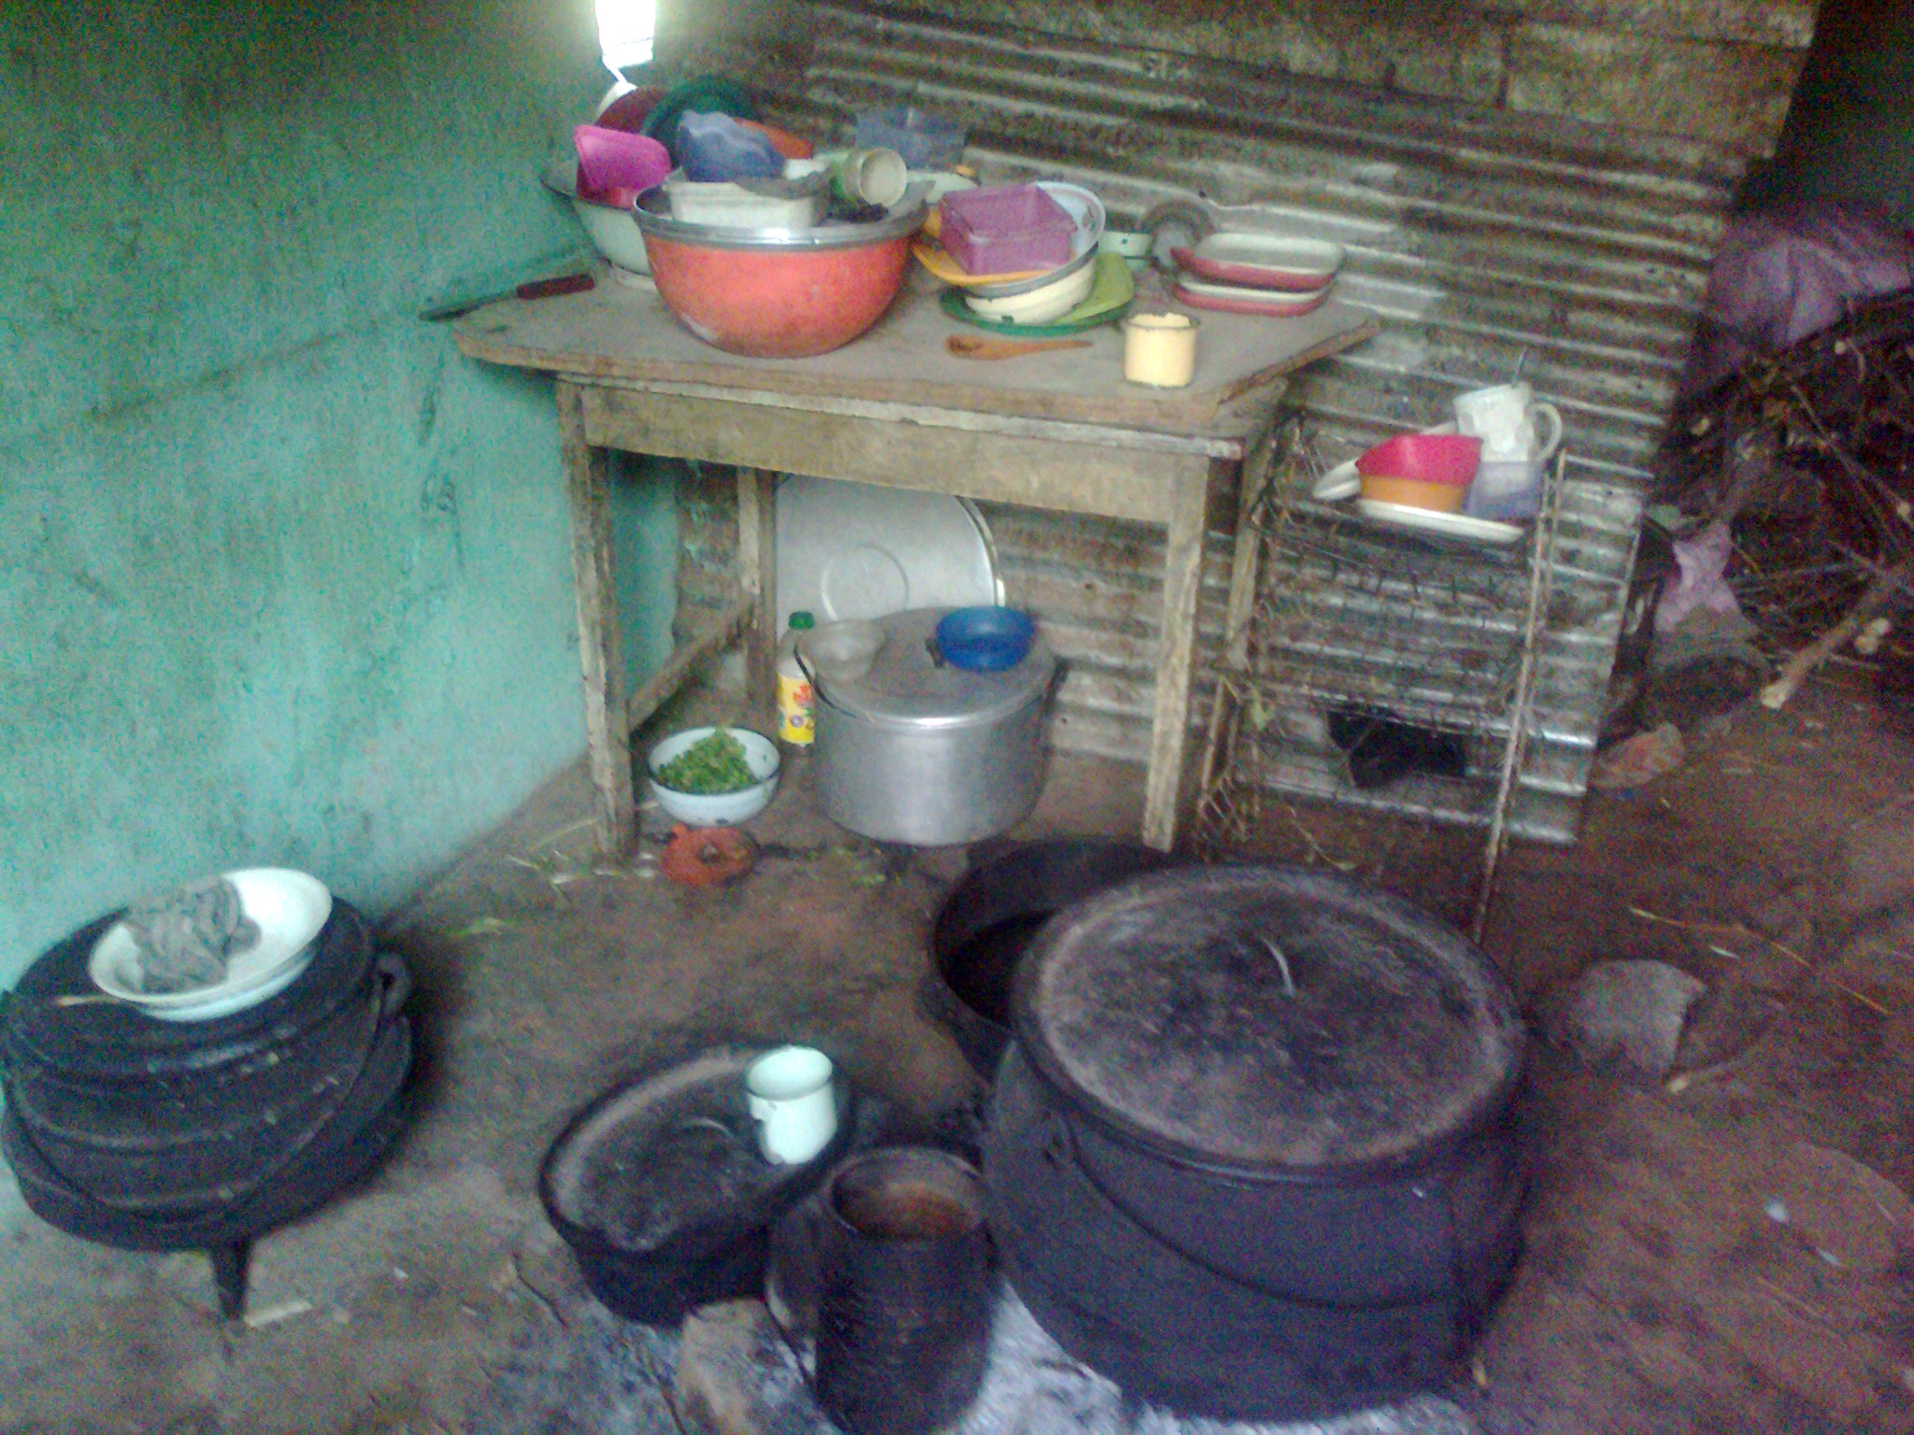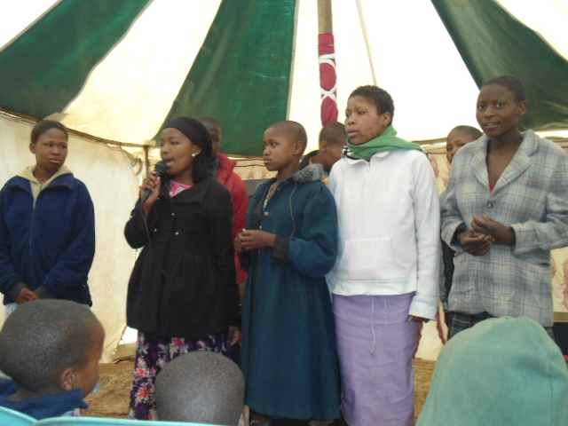
Kitchen
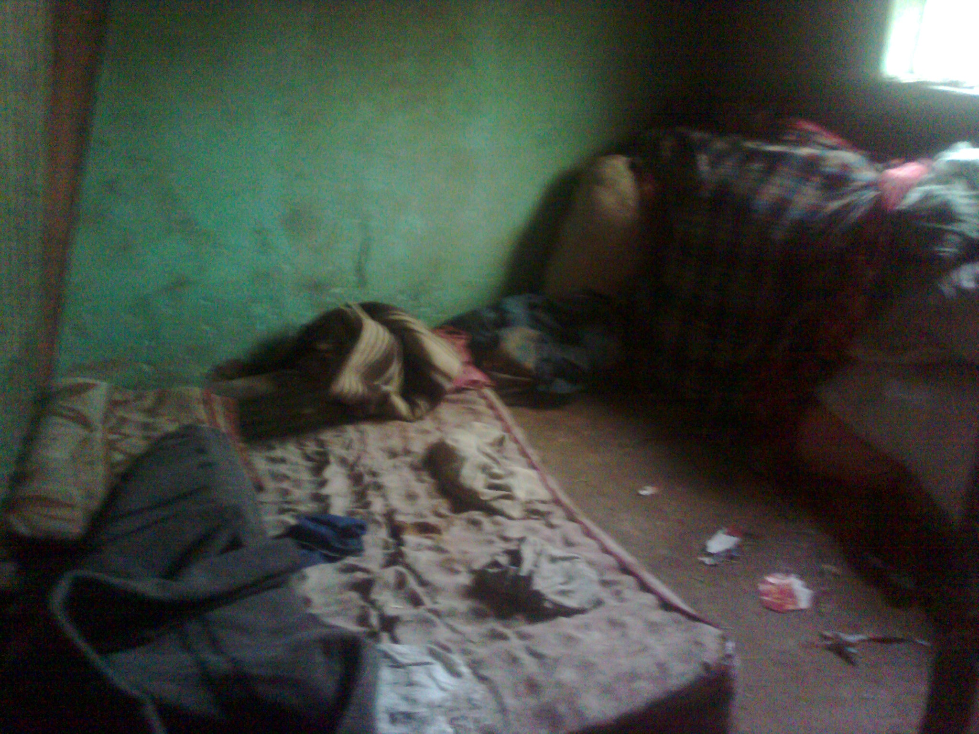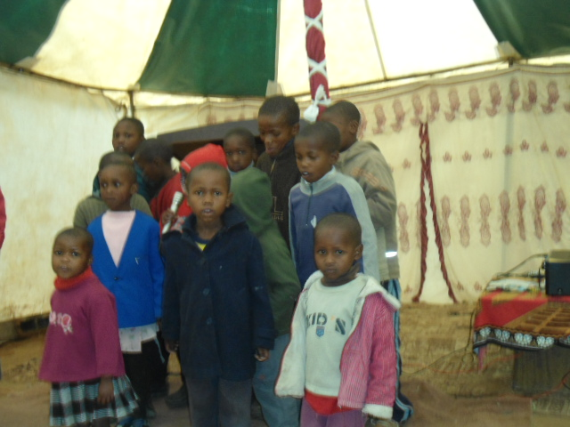
Bedroom

In Ha Ramorakane, there are several children who are malnourished living with their caregivers. These caregivers are old or sick and therefore cannot take proper care of these children. CIL periodically provides these families with clothing and food items and also health talk for breastfeeding mothers in this community. Often times, sick caregivers are referred to nearest health facility.

OUR CHALLENGES/PROSPECTS

It is so sad see these children go back to the street after our weekly activities with them. The centre would want to do more for these children than attending to their needs only on weekly basis. We would love to extend these services to daily activities but are financially constrained. We would specially love to house them in a transition home before they are finally reunited with their families and society.

It has also been discovered that some of them are interested in formal while others in informal education. We plan to enroll those interested in their chosen vocation but fear that our intervention might not be very helpful if they still live on the street.
We have being able to stop some of them who are substance abusers through counseling of which three returned home to their families.

Children are the hope and future of tomorrow, help CIL to help these children have a truly sustainable future.

RECOMMENDATION AND WAY FORWARD

Where there is Help, there is a way.

The little we do for these children would not be possible without the generosity of some individuals and organization in Lesotho.
CIL is calling on individuals and organizations to assist in any way that would enable the Centre to help the street children, orphaned and vulnerable children in Lesotho and create a brighter future thus putting a smile on their faces and a tomorrow to look forward to.

God Bless you.

